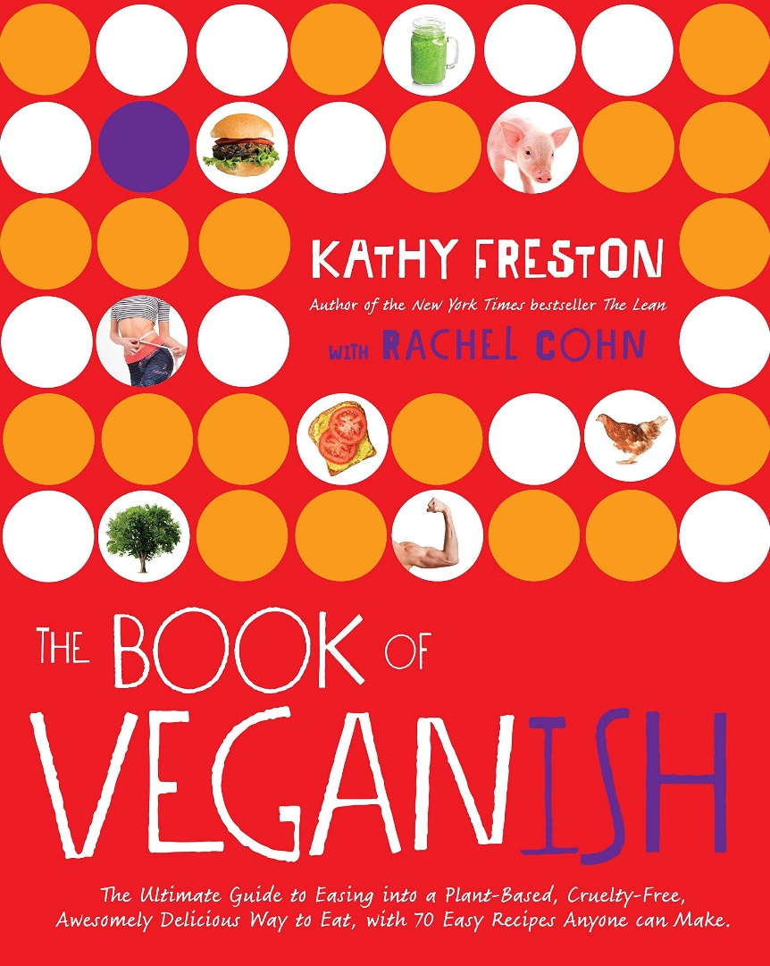

The Book of Veganish: The Ultimate Guide to Easing into a Plant-Based, Cruelty-Free, Awesomely Delicious Way to Eat, with 70 Easy Recipes Anyone can Make

By Kathy Freston

The Book of Veganish contains everything curious young adults need to help them navigate through the transition to a vegan lifestyle. The 70 simple recipes are perfect for those with tight budgets and rudimentary cooking tools (and skills). Filled with insights on the benefits of adopting a plant-based diet and how to best deal with parents and the rest of the nonvegan world, The Book of Veganish will allow existing and aspiring vegans to feel confident about their new lifestyle choices.